

Kickstart Your Career with an Internship at Beech Brook!
Gain valuable skills and hands-on experience with children and families. We offer school-based, outpatient services, foster care, early childhood, and more!

Benefits of joining the Beech Brook Internship Program:
- Engage with clients and gain trauma-informed care experience.
- Develop the skills needed to become an independent licensed practitioner through weekly supervision, program instruction, and agency resources.
- Our largest program, the School-Based department, will provide experience working with diverse student bodies in a school setting. We have the most availability for field
placements in this program.
- Interns may need to be available during the school day if they work with children during the school year.
- Flexibility in earning your required hours and achieving your desired goals.
- Opportunities to attend agency trainings to develop skills and clinical knowledge.
- Eligible placement for the Great Minds Fellowship.
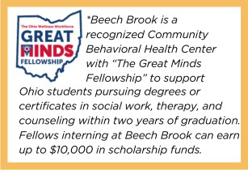

Requirements:

How to Join our Team!
Apply at www.beechbrook.org/internships

- Undergraduates working towards a degree in social work or psychology.
- Graduate students working towards a degree in social work, counseling, or marriage and family therapy.
- Psychology students must complete 6+ hours per week, enroll in the PSY 391 internship course for 2-4 credits. Apply at https://artsandsciences.csuohio.edu/psychology/internship-opportunities

*CPR training and background checks must be completed (handled at Beech Brook with no cost).

